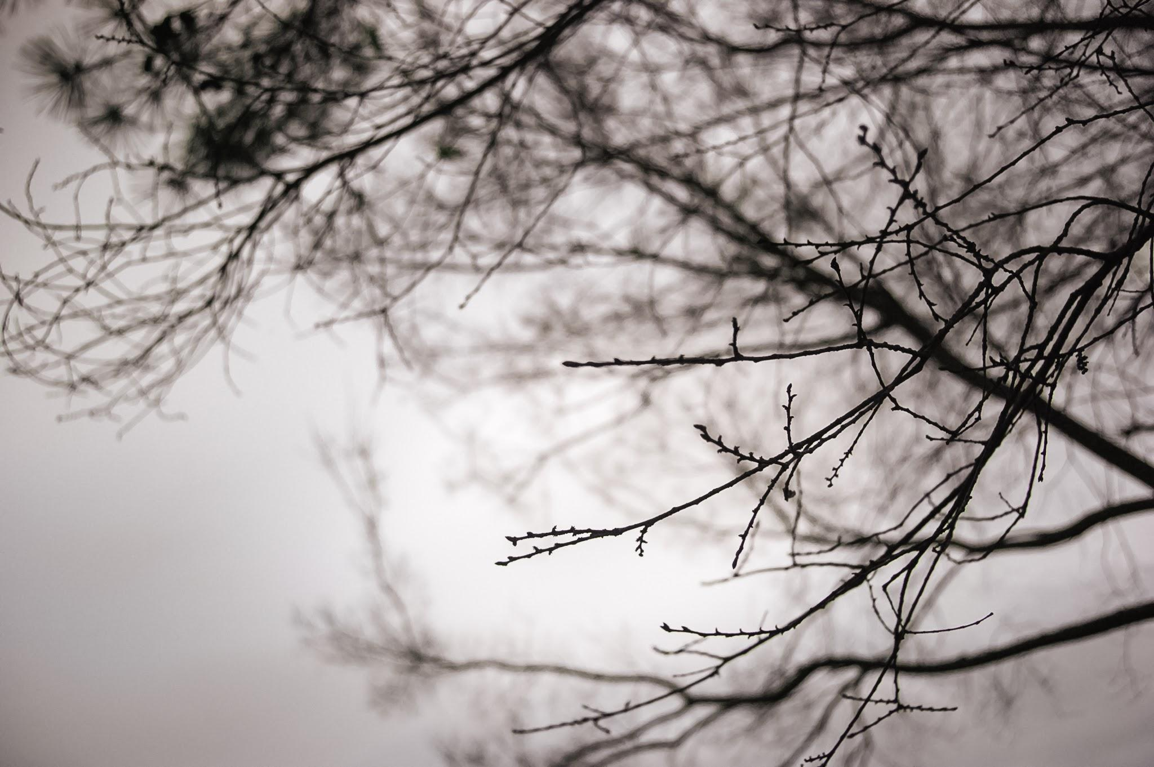
Diego Flores, 2017

Diego Flores

1 Morgan Place, Yellow Springs. OH, 45387
dflores@antiochcollege.edu
(832)217-0492

Education: Computer & Language Skills:
High School: YES Prep North Central Fluent in Spanish (can read and write)
Graduation date: June 2017 Microsoft OS & Microsoft
College: Antioch College Adobe Photoshop & Adobe Lightroom
Expected Graduation date: May 2021 Excel & Google Sheets
ACT: 27 Digital Photography Printing

Honors and Awards:
- Publications (November 2014, July 2016, September 2017)
  - Published in Barrio Writers 7th-8th edition and Creative Communications 2015 Spring Edition
- Art Gallery Exhibitions (May-June 2015, May-June 2016, July-August 2016, May-June 2017, May- July 2017)
  - Pieces on adversity, anthropomorphic impacts on (non)human environments and temptation were presented at the school level, the district (3 years in a row), at Art League Houston and at the Houston Center for Photography
- Service Project Recognition (May 2017)
  - Service group was recognized for service project completion with 40 hours
- Visual Arts Scholastic Event (VASE) 4th Division Placements (February 2016-2017)
  - Competed at the AP Art level in art competitions and received a medal two years in a row for placing in the highest division
- Physics Climber Award (February 2016)
  - Recognized for outstanding improvement due to an increase in performance by exemplifying arduous work ethic and motivation
- English One Excellence Award (May 2014)
  - Awarded for demonstrating comprehension and insight of the literary material, advanced control of language and development of complex ideas

Extracurricular Activities:
- Students With Ambition Go (SWAG) to college mentee (May 2017-present)
  - Mentors two high school students from underserved communities weekly on how to prepare for college academically, financially and socially
- Houston Center for Photography Collaborations (January-May 2017)
  - Studied how to improve photographic technique analyze complex topics and concepts; had piece displayed at the Houston Center for Photography and had another sold at a print sale
- High School Photography Club (August 2016-May 2017)
  - Critiques on technique, style and digital edits; photographs school events
- Advocates and Allies (January 2016- May 2017)
  - Founded the LGBTQIA+ organization to provide a comfortable and educational environment for students to work towards improving the overall school community
- Morning Crew (August 2014-May 2015)
  - Collaborated with peers in order to organize effective and enjoyable Morning Meetings (weekly 20 minute school-wide assemblies)

Extracurricular Summer Involvement:
- Barrio Writers (June 2015, July 2016, July 2017)
  - A founding cohort of the creative writing workshop and served as both a participant and mentor
  - Received accolade from Richard Blanco, 2013 Inaugural Poet, on his poem “I love” (published in BW 7th Edition) after his 2015 presentation at the University of Houston’s Center for Diversity & Inclusion
- UH UEP Summer Bridge Program (June 14-17, 2017)
  - Participant in a strenuous summer program intended to prepare high school graduates for college
- Art League Studio Art Intensive (June 2016- July 2016)
  - Exposed to fine art methods and experimented with different techniques, styles, media and concepts

Volunteering/Community Service and Work Experience:
- High School Service Project (March 2017-April 2017)
  - Researched food insecurity at University of Houston as part of a group service project on hunger in the community
- YES Prep North Central Tutor (March 2014-April 2014)
  - Tutored sixth grade students in nonfiction reading comprehension in preparation for the state STAAR exam

Diego Flores, 2017

